User Manual
<The Jungle Game>

LI Hang Chun 23081548D
Chung Man Fai 23082538D
Huang Lok Shu 23079879D

Introduction
The Jungle Game is a two-player text-based strategy game. The gameboard consists of seven columns and nine rows of squares. Players can move their animal-themed chess across the square of the gameboard. There are some special squares on the gameboard. Such as the dens, traps and rivers. Players can get victory by capturing all the opponent’s chess or getting his own chess into the opponent’s dens.

Game Rule
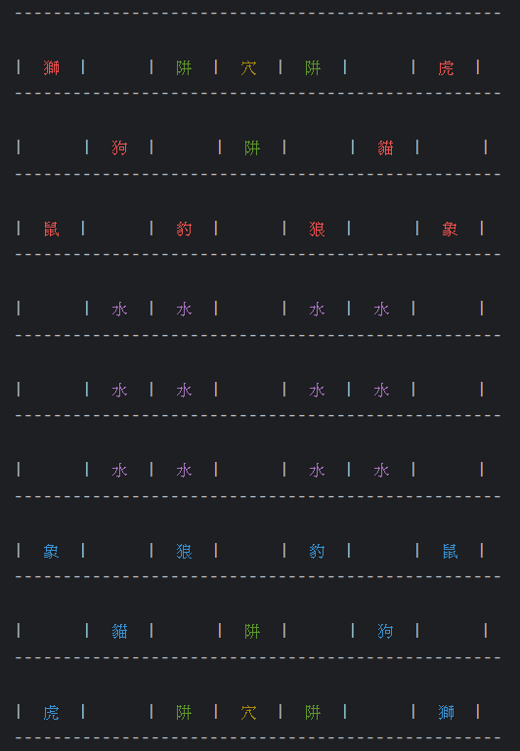
Board:
A board of the Jungle game consists of seven columns and nine rows of squares. Chinese names of eight animals appear on each side of the board to indicate the initial placement.
There are several special squares and areas on the Jungle board: The dens (yellow Chinese letter) are in the center of the boundary rows of the board. Traps (green Chinese letter) are located to each side and in front of the dens. Two water areas or rivers (purple Chinese letter) are in the center of the board: each comprises six squares in a 2X3 rectangle. There are single columns of ordinary land squares on the edges of the board and down the middle between the rivers.

Pieces:
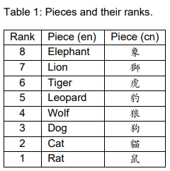
Each side has eight pieces representing different animals, each with a different rank. Higher ranking pieces can capture all pieces of identical or lower ranking. However, there is one exception: The rat may capture the elephant, while the elephant may not capture the rat. The animal ranking, from highest to lowest, is as shown in Table 1.

Movement:
Players take turns moving. On each turn, a player is required to make a move. Every piece may move exactly one square, either horizontally or vertically—diagonal movement is not allowed. Pieces are disallowed to enter their own den. Additionally, following special movement rules apply to water squares:
- The rat is the only type of animal that is allowed to go onto a water square.
- The rat may not capture the elephant or another rat on land directly from a water square. Similarly, a rat on land may not attack a rat in the water.
- The rat may attack the opponent rat if both pieces are in the water or on the land.
- The lion and tiger pieces may jump over a river by moving horizontally or vertically. They move from a square on one edge of the river to the next non-water square on the other side. Such a move is not allowed if there is a rat (whether friendly or enemy) on any of the intervening water squares. The lion and tiger are allowed to capture enemy pieces by such jumping moves.

Capturing
Animals capture the opponent pieces by “eating” them. A piece can capture any opponent’s piece which has the same or lower rank, with the following exceptions:
- A rat may capture an elephant (but not from a water square).
- A piece may capture any enemy piece in one of the player's trap squares, regardless of rank.

Objective:
The goal of the game is to move a piece onto the den on the opponent's side of the board or capture all the opponent's pieces.

Set Up Environment
To execute this application, the users need to install JDK22 on their devices. Furthermore, their devices should run Operating System that supports command line console, for example, Windows and Linux.

Getting Started
Inside the “src” file, there are three directories: Controller, Model, View. Each directory represents a component of the MVC model. Also, there is a “Main.java” file inside the “src” file. If user wants to start the game, the user needs to run the “Main.java” file. In the command-line console, users need to type “javac Main.java” the first time they run the application, and “java Main.java” each time they want to execute it. (Make sure you are in the correct directory.)
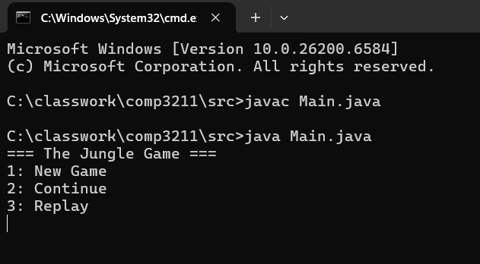
When user runs the “Main.java” file, the system will ask whether user wants to start a new game in console, continue a previous game and replay a match of a game.
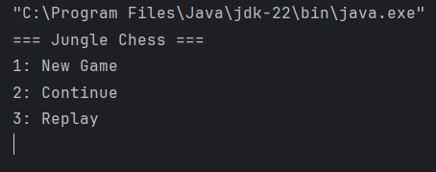
- By typing “1” in the console, users can start a new game.
- By typing “2” in the console, users can continue a saved match.
- By typing “3” in the console, users can replay a record of a match.

Player Name
Then, the users need to determine their players’ name. The system will ask user either to input their name manually or use the players’ name generated by system.
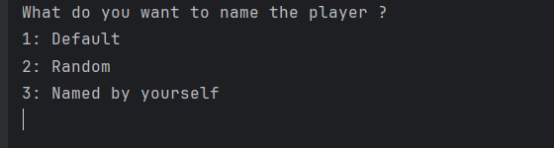
- By typing “1” in the console, users can use default names.
- By typing “2” in the console, users can request system to generate two random names
- By typing “3” in the console, users can input their names.

Record Game
The users can determine whether to record current game and players’ status.
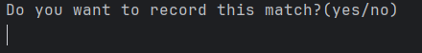
- By typing “yes” (for both upper case and lower case) in console, the system will record whole match and players’ status.
- By typing “no”, the system will not record anything. (Any non- “yes” input will be considered as “no” by the system.)
If users decide to record whole match, users need to name the record. The record file will be saved with “.record” extension.
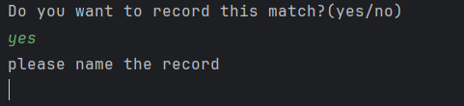

Pieces Movement Commands
After setting up basic information for new match, the system will display initial game board in console.

Then, the system will ask users to determine which piece they want to move. Users will take turns moving their pieces. (Player 1 will move pieces with red color first.)
- By typing a name of an animal piece (Elephant, Lion, Tiger, Leopard, Wolf, Dog, Cat, and Rat) in the console, the users can control the movement of that piece.
- By typing “display” in the console, the system will present current game board and both players remaining pieces.

The system will ask users to determine which direction of chosen piece they want to move.
- By typing a direction (up, down, left, right) in the console, the chosen piece will move to respective direction.
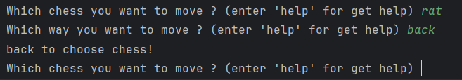
- By typing “back” in the console, the users can back to select which piece they want to move.
Example (player 1 move rat piece to down a square):
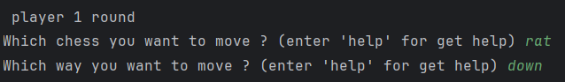
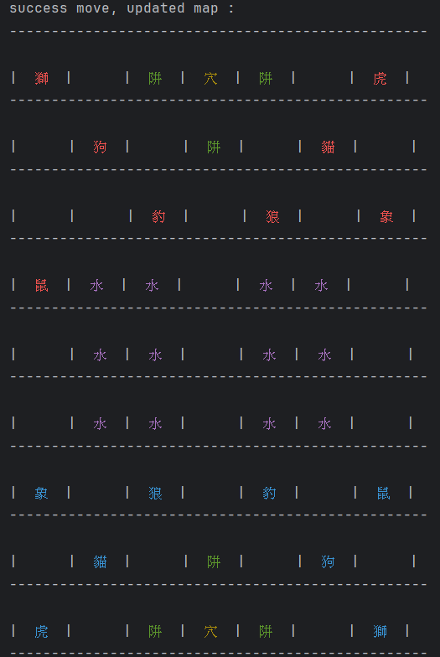
Undo movements
The users can undo piece movements when they are asked to move pieces. Each player can undo up to the three most recent moves in the current game, but the total number of undo actions by that player across the entire game cannot exceed three.
- By typing “undo” in the console, the system will undo both players’ previous movements. Users can type consecutively “undo” in console 3 times for undoing 3 previous movements.
Example:
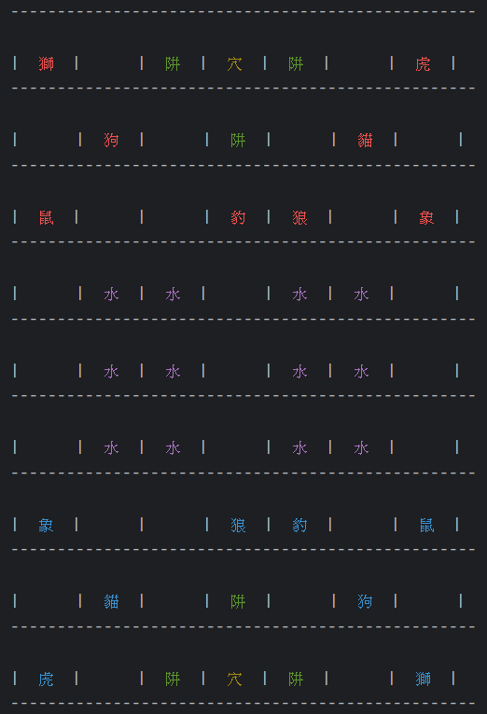
Undo

Save game
The users can save an ongoing game when they are asked to move pieces.
- By typing “save” in console, the system will save current game board, pieces’ position and players’ status.
When users decide to save the current game, they need to provide a name for the save. The game will be stored in a file with the “.jungle” extension.
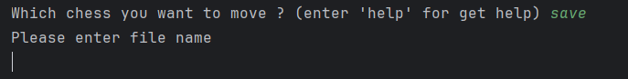

Continue game
At the beginning, if users choose to continue a saved match. The users need to input the name of saved match. (The extension “.jungle” is not required to input.)
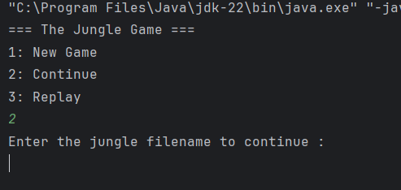

Replay game
At the beginning, if users choose to replay a record of a match. The users need to input the name of record. (The extension “.record” is not required to input.)
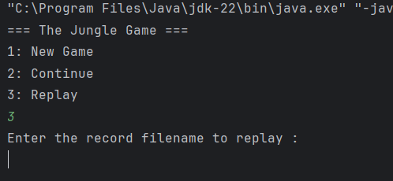

Invalid request handling
When the users input invalid command or request, the system will respond to respective error messages for users to correct requests. Invalid requests include invalid movements of pieces, inputting duplicate players’ names, saving file with duplicate name, and opening non-exist file etc.

